Workshop 2002 "Light in Landscape and Art projects" in Alingsås/S
The parking lot
Headed by:
Leni Schwendinger/USA
Participants:
Steffen Bauer/D
Kamar Finn/IL
Charlotta Angerdal/S
Andreas Ermisch/D
Ron Scaglione/GB
Susanna Udd/S
Wichuda Watbumroongskul/S
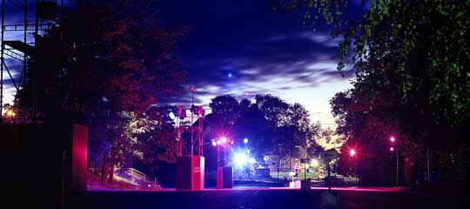
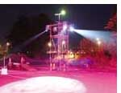
A flat, paved 3200 square metre railway station parking lot is home to 100 cars during the day when their owners commute to nearby Gothenburg. After dark, the parking lot is empty. Leni's group decided to transform it into a skaters' and bikers' paradise using moving lights. The workshop students interviewed local youngsters about their activities and how they would like to see the space for their uses. This workshop group was an experiment for more reasons than one: the group used exclusively sponsored Martin Professional equipment. A Martin technician spent four days helping the group and programming their design concept. The results made a huge impact on visitors and inhabitants of Alingsås, who were a little sceptical about the spectacular "show", but it showed how an urban space can come to life after dark and serve the community twofold. The kids loved it and the equipment was returned unscathed!

